NAAN MUDHALVAN

NAME:Lakshmi Priya K

COURSE:SALESFORCE

NM ID:

978F3E4F792AE68AED84916B52B7A329

Task1:

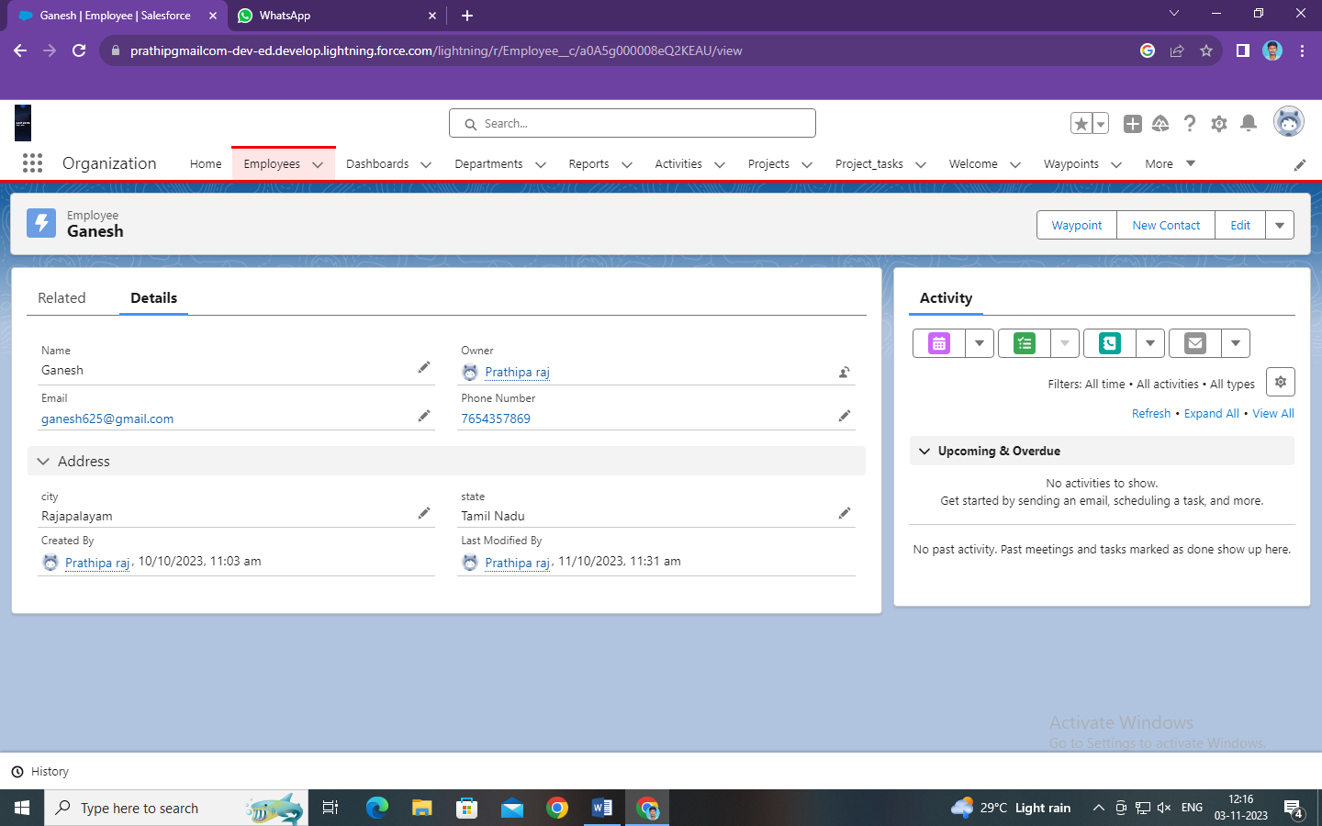

Task 2:

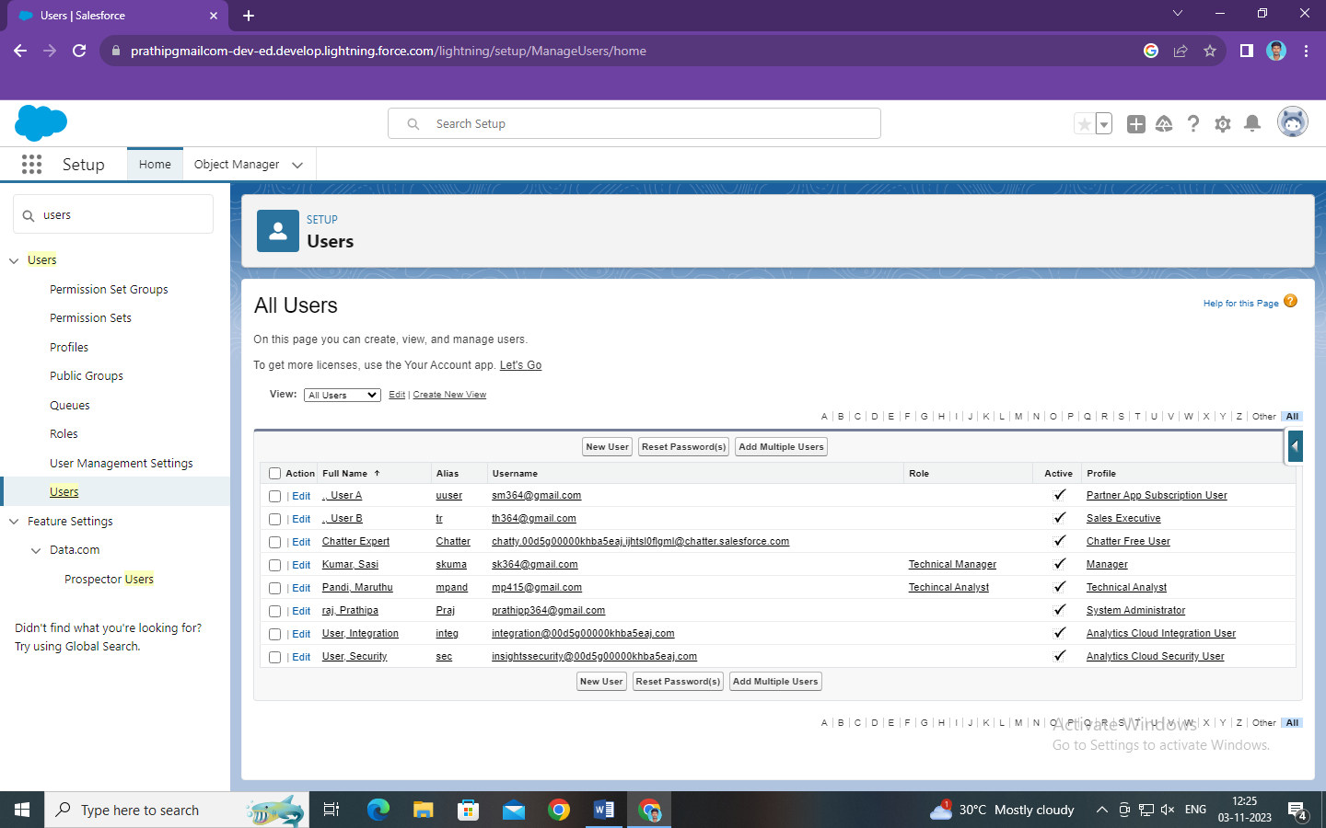

Task 3:

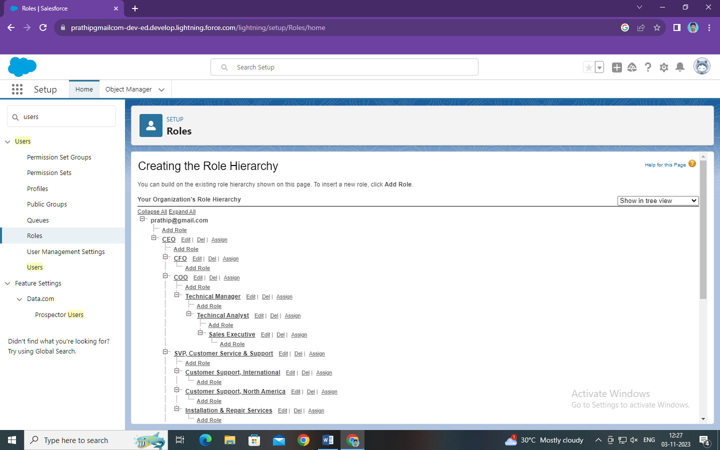

Task 4:

